Login proof Server

Login proof client

List proof server

List proof Client

Logout proof server

Logout proof client

Who proof server (Fail? Maybe I don’t understand)

Who proof client (no output on client side)

Lookup proof server (invalid search)

Lookup proof client (invalid search)

Lookup proof server (Valid Charizard)

Lookup proof client (Valid Charizard)

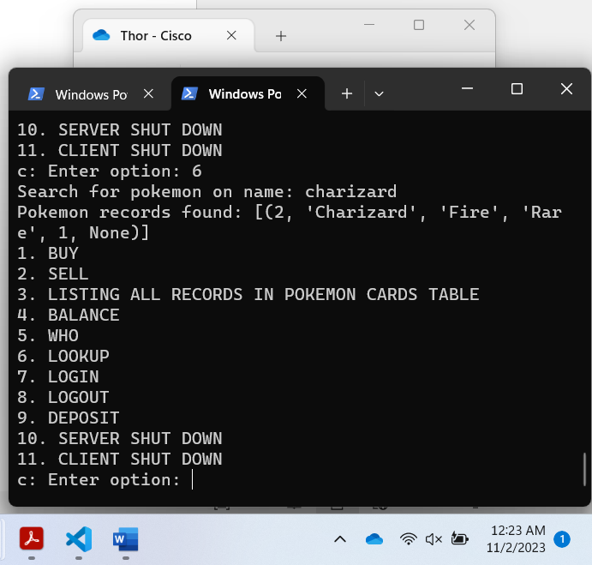

Deposit proof server

Deposit proof client (showing valid and invalid attempts)

